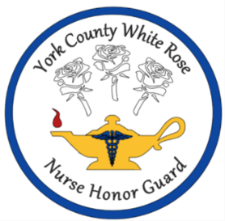**York County White Rose Nurse Honor Guard**

**Tribute Uniform Resources**

**CAP:** optional white cap pinned securely; nursing school graduation cap is acceptable

Kay’s Caps, Inc. “Nurse Cap 749”: 3 ¼” Cuff Two Button $17.69; consider ordering several,

together with others, to save on shipping, if desired

<https://kayscaps.com/749/>

**CAPE:** Navy blue (solid) outer lined and red (solid) inner lined cape

Julie Murray: [jmury581@gmail.com](mailto:jmury581@gmail.com)

326 Trestle Drive Dimondale, Michigan 48821 517-285-0295 $65; consider ordering several, together

with others, to save on shipping, if desired

**JACKET/VEST:** Navy blue (solid) classic business suit jacket/blazer/vest (minimum 2 button)

**CLASP (for Cape):** Amazon “WANDIC Vintage Swirl Flower Cape Fastener (sew on) Hook and Eye, Silver”

6 full sets for $9.99 <https://www.amazon.com/dp/B09SKLML5C/?coliid=I3S5C38VAU47Y7&colid=V7OY8E0KH26M&psc=1&ref_=list_c_wl_lv_ov_lig_dp_it>

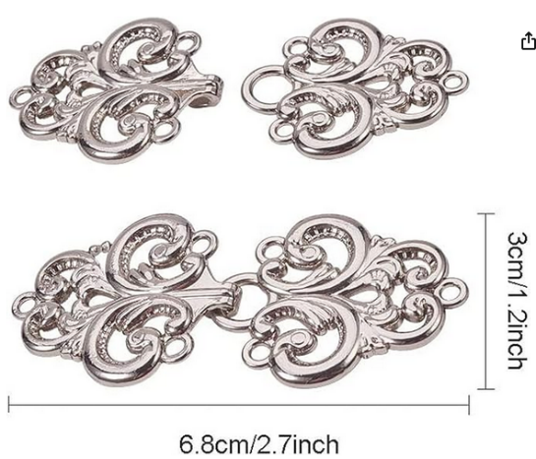

**WHITE SHOES, CLOTHING:** Full white dress (length at or below knee) or white top and pants or skirt

(length at or below knee) and white shoes; white or flesh underclothing; white leg coverings (pantyhose, tights, leggings, socks)

Regarding fit/style: whatever looks ok, fits and works for you; Super Shoes, Amazon have some options

* Nursing school pins may be worn on the wearer’s left side/collar of the cape, vest, or jacket
* Hair may be worn down or pulled back
* Simple, unobtrusive jewelry acceptable
* Overall modest, respectful appearance
* Exceptions considered by written request to Board of Officers